ME540 Homework Week 8 Andrew Alferman, Zoe Lavrich

Homework for week 8 focused on Kinetic Theory of gases. First a dimensionalized version of the distribution Φ for nitrogen gas (N2) at temperatures of 200, 273 and 400 [K] as shown in Figure 1 was plotted based on the equations below, in which m is the particle mass and T is the temperature in Kelvin:

Figure 1. dimensionalized distribution for Nitrogen at 1)200K, 2)273 K, and 3)400K



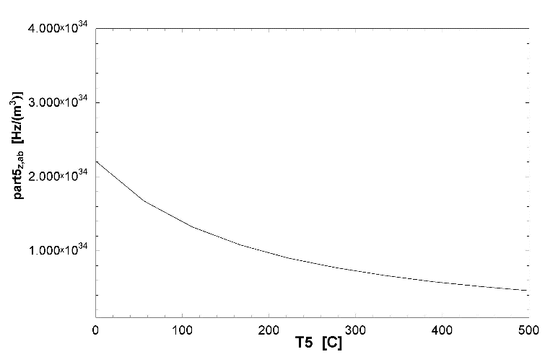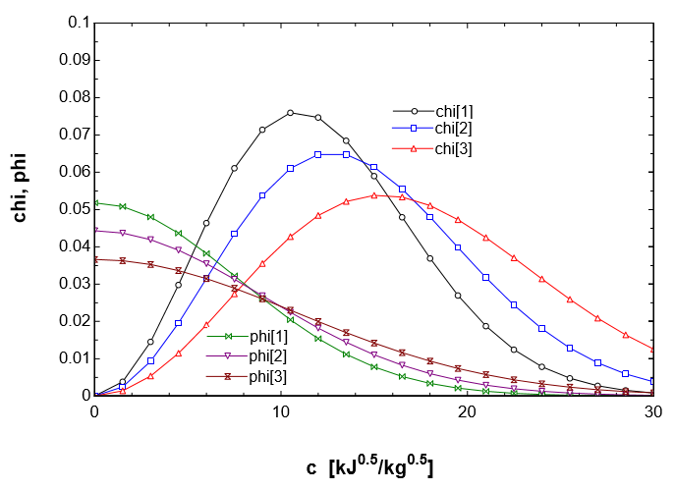

Figure 2. nondimensionalized distribution for Nitrogen at 1)200K, 2)273K and 3)400K

The most probable speed of 402.6 m/s, average speed of 454.2 m/s and root-mean-squared speed of 493 m/s of the Nitrogen molecules at 273K were then calculated based on the following equations:



Figure 3. Collision frequency of oxygen.





Figure 8 from page 45 of Vincenti and Kurger was then recreated as shown in Figure 2 using the equations below:







Assuming Van der Waals radii of 152 and 155 pm for oxygen gas (O2) and nitrogen gas (N2) respectively, the collision rate of O2 with N2 in air at a total pressure of 1 atm and a temperature of 0°C was determined to be 2.208E+34 Hz/m3 based on the equation:

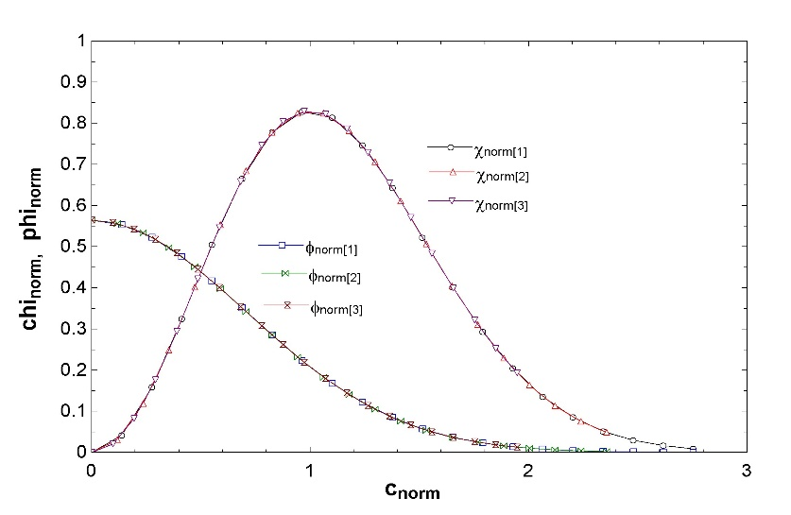

As Figure 3 shows, the collision frequency for oxygen decreases as temperature is increased. As the temperature increases the motion (internal energy) of the molecules should also increase. If the particles were in a confined space, we might expect the increase in motion to result in an increase in collisions. However, in this case, since the gases are not confined and the pressure is constantly atmospheric, the particles spread out (the specific volume increases) and collisions become less frequent.

The mean free path of the oxygen molecules of 9.152E-08 m was calculated using the simplified equation:

